VEHICLE SERVICE CENTRE MANAGEMENT SYSTEM

Name: K. Devika
Roll No: 25WU0102120
Course: Database Management System(DBMS)
Faculty Name: Kiran Mayee
Academic Year: 2026-27

TABLE OF CONTENTS
1. Cover Page
2. Abstract
3. Introduction and Problem Statement
4. Objectives and Scope
5. Software and Hardware Requirements
6. ER Diagram
7. Relational Schema and Normalization
8. Data Dictionary
9. SQL Commands Used (DDL, DML) with Sample Outputs
10. Queries with Outputs
11. UI Design and Screenshots
12. Implementation Details
13. Testing
14. Conclusion and Future Enhancements
15. References
16. Appendix: GitHub Repository Link

2. Abstract
Vehicle service centres handle a continuous flow of customers, vehicles, appointments, repair tasks, mechanics, spare parts and payments. When these records are maintained manually or in scattered spreadsheets, they are prone to duplication, inconsistency and loss, and it becomes difficult to answer simple questions such as which jobs are pending, how much stock remains or how much revenue has been earned.
This project presents the design and implementation of a relational Database Management System for a Vehicle Service Centre. The system is modelled using an Entity–Relationship diagram and converted into a normalized relational schema of twelve tables: CUSTOMER, VEHICLE, SERVICE_BOOKING, JOB_CARD, TASK, MECHANIC, ASSIGNMENT, INSPECTION, SPARE_PART, PART_USAGE, INVOICE and PAYMENT. Data integrity is enforced through primary keys, foreign keys, UNIQUE, NOT NULL, DEFAULT and CHECK constraints.
The database was implemented in MySQL, populated with sample data, and validated using ten SQL queries covering selection, joins and aggregation, along with constraint-level test cases. The result is a consistent, well-structured data foundation on which a complete service-centre management application can be built. A Python Tkinter desktop interface connected to the database allows records to be viewed, inserted and deleted.
Keywords: DBMS, MySQL, Python, Tkinter, ER Diagram, Normalization, Vehicle Service Centre, SQL

3. Introduction and Problem Statement

3.1 Introduction
A vehicle service centre provides maintenance and repair services such as oil changes, brake repairs, engine tuning, AC servicing and wheel alignment. A single visit involves many connected pieces of information: who the customer is, which vehicle they brought, when the service was booked, what inspection revealed, which tasks were performed by which mechanic, which spare parts were consumed, and how the final bill was paid.
A Database Management System (DBMS) stores this information in a structured, shared and secure manner, allowing it to be queried quickly and kept consistent. The relational model, in which data is organised into tables linked by keys, is the natural choice for this domain because the data is highly structured and the relationships between entities are well defined.

3.2 Problem Statement
Many small and medium service centres still depend on paper registers or loosely maintained spreadsheets. This leads to the following problems:
- Customer and vehicle details are recorded repeatedly, causing redundancy and inconsistency.
- There is no reliable link between a booking, the work performed, the parts consumed and the final invoice.
- Mechanic workload and task history cannot be tracked easily.
- Spare-part stock and usage are not recorded systematically.
- Billing and payment records are hard to reconcile, and revenue reports take considerable manual effort.
The problem addressed by this project is to design and implement a relational database that captures the complete service workflow — from customer registration to payment — while guaranteeing data integrity and supporting useful analytical queries.

4. Objectives and Scope

4.1 Objectives
- To analyse the functional requirements of a vehicle service centre and identify its entities and relationships.
- To design an ER diagram that models customers, vehicles, bookings, job cards, tasks, mechanics, inspections, spare parts, invoices and payments.
- To convert the ER diagram into a relational schema and normalize it up to Third Normal Form (3NF).
- To implement the schema in MySQL using DDL statements with appropriate keys and integrity constraints.
- To populate the database with realistic sample data using DML statements.
- To write and verify SQL queries that retrieve, join and summarise the stored information.
- To test the database against valid and invalid inputs to confirm that constraints behave correctly.

4.2 Scope
The project covers the database and a desktop interface for the service centre system:
- Registration of customers and their vehicles.
- Service booking and job card creation (one job card per booking).
- Task management and assignment of tasks to mechanics with start and end times.
- Recording inspection findings and spare-part usage per job card.
- Invoice generation and recording of payments by Cash, Card, UPI or Online mode.
- A Python Tkinter desktop interface to view, insert and delete records in all twelve tables.
Out of scope: payroll, supplier and purchase management, customer loyalty programmes, and online payment-gateway integration. Spare-part stock is stored but is not automatically reduced when parts are used; this is listed as a future enhancement.

5. Software and Hardware Requirements

5.1 Software Requirements
Component | Specification
Operating System | Windows 10 / 11
Database | MySQL Server 8.0
Database Client | MySQL Workbench
Programming Language | Python 3.x
GUI Library | Tkinter (included with Python)
Database Connector | mysql-connector-python
Code Editor | Visual Studio Code
Diagramming / Slides | Canva
Version Control | Git and GitHub

5.2 Hardware Requirements
Component | Minimum Specification
Processor | Intel Core i3 or equivalent
RAM | 8 GB
Storage | At least 1 GB of free disk space
Display | 1366 × 768 resolution or higher
Other | Keyboard, mouse; internet connection for GitHub access

6. ER Diagram
The Entity–Relationship diagram below models the Vehicle Service Centre. Rectangles represent entities, ellipses represent attributes (underlined attributes are primary keys), and diamonds represent relationships with their cardinalities.
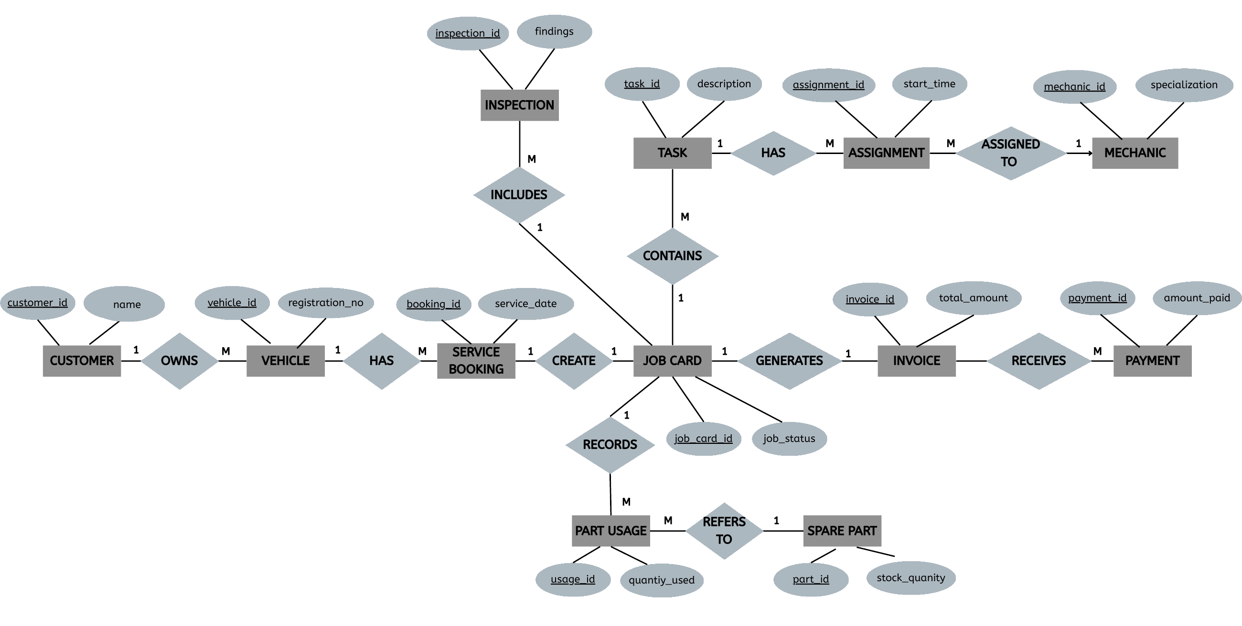
Figure 6.1: ER diagram of the Vehicle Service Centre Management System

6.1 Relationships and Cardinality
Entity A | Relationship | Cardinality | Entity B / Explanation
CUSTOMER | OWNS | 1 : M | VEHICLE – a customer may own many vehicles
VEHICLE | HAS | 1 : M | SERVICE_BOOKING – a vehicle can be booked many times
SERVICE_BOOKING | CREATE | 1 : 1 | JOB_CARD – each booking produces one job card
JOB_CARD | CONTAINS | 1 : M | TASK – a job card contains many tasks
JOB_CARD | INCLUDES | 1 : M | INSPECTION – a job card has inspection records
JOB_CARD | RECORDS | 1 : M | PART_USAGE – parts consumed on the job
SPARE_PART | REFERS TO | 1 : M | PART_USAGE – a part can be used many times
JOB_CARD | GENERATES | 1 : 1 | INVOICE – one invoice per job card
INVOICE | RECEIVES | 1 : M | PAYMENT – an invoice may be paid in instalments
TASK | HAS | 1 : M | ASSIGNMENT – a task can have assignment records
MECHANIC | ASSIGNED TO | 1 : M | ASSIGNMENT – a mechanic handles many assignments

The many-to-many relationship between TASK and MECHANIC is resolved through the ASSIGNMENT entity, which also stores the start and end time of the work.

7. Relational Schema and Normalization

7.1 Relational Schema
The ER diagram was mapped to the following relational schema. Primary keys are underlined in the data dictionary and foreign keys are marked FK.
Relation | Attributes
CUSTOMER | Customer_ID (PK), Name, Phone, Email
VEHICLE | Vehicle_ID (PK), Registration_No, Model, Customer_ID (FK)
SERVICE_BOOKING | Booking_ID (PK), Service_Date, Status, Vehicle_ID (FK)
JOB_CARD | Job_Card_ID (PK), Created_Date, Job_Status, Booking_ID (FK)
TASK | Task_ID (PK), Description, Labour_Charge, Job_Card_ID (FK)
MECHANIC | Mechanic_ID (PK), Name, Specialization, Phone
ASSIGNMENT | Assignment_ID (PK), Start_Time, End_Time, Task_ID (FK), Mechanic_ID (FK)
INSPECTION | Inspection_ID (PK), Inspection_Date, Findings, Job_Card_ID (FK)
SPARE_PART | Part_ID (PK), Part_Name, Stock_Quantity, Unit_Price
PART_USAGE | Usage_ID (PK), Quantity, Job_Card_ID (FK), Part_ID (FK)
INVOICE | Invoice_ID (PK), Invoice_Date, Total_Amount, Job_Card_ID (FK)
PAYMENT | Payment_ID (PK), Payment_Date, Amount, Payment_Mode, Invoice_ID (FK)

7.2 Changes from the Initial Schema
During implementation the initial schema presented earlier was refined as follows:
- INVOICE: the derived attributes Labour_Total and Parts_Total were removed. Both can be calculated from TASK and PART_USAGE, so only Total_Amount is stored as the billed value.
- PAYMENT: Amount_Paid and Payment_Method were renamed to Amount and Payment_Mode, and a CHECK constraint restricts the mode to Cash, Card, UPI or Online.
- PART_USAGE: Quantity_Used was renamed to Quantity.
- Integrity constraints (UNIQUE, CHECK, DEFAULT) were added to every table.

7.3 Normalization
First Normal Form (1NF). Every table has a primary key, every column holds a single atomic value, and there are no repeating groups. For example, a job card with several tasks is not stored in one row; each task is a separate row in TASK linked by Job_Card_ID.
Second Normal Form (2NF). All tables are in 1NF and every primary key is a single column, so no non-key attribute can depend on only part of a key. Hence there are no partial dependencies.
Third Normal Form (3NF). No non-key attribute depends on another non-key attribute. Customer details are kept only in CUSTOMER and not repeated in VEHICLE; the part name and unit price are stored only in SPARE_PART and referenced from PART_USAGE; mechanic details are stored only in MECHANIC and referenced from ASSIGNMENT. This removes update, insertion and deletion anomalies.
Boolean Codd Normal Form (BCNF). In each table the only determinants are candidate keys (for example Customer_ID, Phone and Email in CUSTOMER; Vehicle_ID and Registration_No in VEHICLE), so the schema also satisfies BCNF.
Note on INVOICE.Total_Amount. Total_Amount is a derived value (labour charges plus the price of parts used). It is deliberately retained as a snapshot of the amount billed, so that later changes to a part’s Unit_Price do not alter historical invoices.

8. Data Dictionary
The tables below describe the structure of every table, including data types and constraints. PK = Primary Key, FK = Foreign Key.

8.1 CUSTOMER
Stores customer details.
Column | Data Type | Constraint | Description
Customer_ID | INT | PRIMARY KEY | Unique customer identifier
Name | VARCHAR(100) | NOT NULL | Customer name
Phone | VARCHAR(15) | NOT NULL, UNIQUE | Contact number
Email | VARCHAR(100) | UNIQUE | E-mail address

8.2 VEHICLE
Vehicles owned by customers.
Column | Data Type | Constraint | Description
Vehicle_ID | INT | PRIMARY KEY | Unique vehicle identifier
Registration_No | VARCHAR(20) | NOT NULL, UNIQUE | Vehicle registration number
Model | VARCHAR(50) | NOT NULL | Vehicle model
Customer_ID | INT | NOT NULL, FK → CUSTOMER | Owner of the vehicle

8.3 SERVICE_BOOKING
Service appointments for vehicles.
Column | Data Type | Constraint | Description
Booking_ID | INT | PRIMARY KEY | Unique booking identifier
Service_Date | DATE | NOT NULL | Scheduled service date
Status | VARCHAR(30) | NOT NULL, DEFAULT 'Booked', CHECK IN (Booked, In Progress, Completed, Cancelled) | Booking status
Vehicle_ID | INT | NOT NULL, FK → VEHICLE | Vehicle being serviced

8.4 JOB_CARD
Work order created for a booking.
Column | Data Type | Constraint | Description
Job_Card_ID | INT | PRIMARY KEY | Unique job card identifier
Created_Date | DATE | NOT NULL | Date the job card was opened
Job_Status | VARCHAR(30) | NOT NULL, DEFAULT 'Open', CHECK IN (Open, In Progress, Completed, Cancelled) | Job progress
Booking_ID | INT | NOT NULL, UNIQUE, FK → SERVICE_BOOKING | Booking this job card belongs to (1:1)

8.5 TASK
Individual tasks within a job card.
Column | Data Type | Constraint | Description
Task_ID | INT | PRIMARY KEY | Unique task identifier
Description | VARCHAR(150) | NOT NULL | Work to be done
Labour_Charge | DECIMAL(10,2) | NOT NULL, CHECK >= 0 | Labour cost of the task
Job_Card_ID | INT | NOT NULL, FK → JOB_CARD | Parent job card

8.6 MECHANIC
Mechanics employed at the centre.
Column | Data Type | Constraint | Description
Mechanic_ID | INT | PRIMARY KEY | Unique mechanic identifier
Name | VARCHAR(100) | NOT NULL | Mechanic name
Specialization | VARCHAR(100) | — | Area of expertise
Phone | VARCHAR(15) | UNIQUE | Contact number

8.7 ASSIGNMENT
Allocation of mechanics to tasks (resolves M:N).
Column | Data Type | Constraint | Description
Assignment_ID | INT | PRIMARY KEY | Unique assignment identifier
Start_Time | DATETIME | NOT NULL | Work start time
End_Time | DATETIME | NOT NULL, CHECK End_Time > Start_Time | Work end time
Task_ID | INT | NOT NULL, FK → TASK | Task being performed
Mechanic_ID | INT | NOT NULL, FK → MECHANIC | Mechanic performing the task

8.8 INSPECTION
Inspection findings for a job card.
Column | Data Type | Constraint | Description
Inspection_ID | INT | PRIMARY KEY | Unique inspection identifier
Inspection_Date | DATE | NOT NULL | Date of inspection
Findings | VARCHAR(255) | — | Observations recorded
Job_Card_ID | INT | NOT NULL, FK → JOB_CARD | Related job card

8.9 SPARE_PART
Spare parts inventory.
Column | Data Type | Constraint | Description
Part_ID | INT | PRIMARY KEY | Unique part identifier
Part_Name | VARCHAR(100) | NOT NULL | Name of the part
Stock_Quantity | INT | NOT NULL, DEFAULT 0, CHECK >= 0 | Units in stock
Unit_Price | DECIMAL(10,2) | NOT NULL, CHECK >= 0 | Price per unit

8.10 PART_USAGE
Parts consumed by a job card.
Column | Data Type | Constraint | Description
Usage_ID | INT | PRIMARY KEY | Unique usage record identifier
Quantity | INT | NOT NULL, CHECK > 0 | Units of the part used
Job_Card_ID | INT | NOT NULL, FK → JOB_CARD | Job card using the part
Part_ID | INT | NOT NULL, FK → SPARE_PART | Part used

8.11 INVOICE
Bill generated for a job card.
Column | Data Type | Constraint | Description
Invoice_ID | INT | PRIMARY KEY | Unique invoice identifier
Invoice_Date | DATE | NOT NULL | Date of billing
Total_Amount | DECIMAL(10,2) | NOT NULL, DEFAULT 0, CHECK >= 0 | Total payable (labour + parts)
Job_Card_ID | INT | NOT NULL, UNIQUE, FK → JOB_CARD | Job card billed (1:1)

8.12 PAYMENT
Payments received against invoices.
Column | Data Type | Constraint | Description
Payment_ID | INT | PRIMARY KEY | Unique payment identifier
Payment_Date | DATE | NOT NULL | Date of payment
Amount | DECIMAL(10,2) | NOT NULL, CHECK > 0 | Amount paid
Payment_Mode | VARCHAR(30) | NOT NULL, CHECK IN (Cash, Card, UPI, Online) | Mode of payment
Invoice_ID | INT | NOT NULL, FK → INVOICE | Invoice being paid

9. SQL Commands Used (DDL, DML) with Sample Outputs

9.1 Database Creation (DDL)
CREATE DATABASE VehicleServiceCentre;
USE VehicleServiceCentre;

9.2 Table Creation (DDL)
The twelve tables were created in dependency order so that every referenced (parent) table exists before the table that refers to it.
1. CUSTOMER
CREATE TABLE CUSTOMER (
Customer_ID INT PRIMARY KEY,
Name VARCHAR(100) NOT NULL,
Phone VARCHAR(15) NOT NULL UNIQUE,
Email VARCHAR(100) UNIQUE
);
2. VEHICLE
CREATE TABLE VEHICLE (
Vehicle_ID INT PRIMARY KEY,
Registration_No VARCHAR(20) NOT NULL UNIQUE,
Model VARCHAR(50) NOT NULL,
Customer_ID INT NOT NULL,
FOREIGN KEY (Customer_ID) REFERENCES CUSTOMER(Customer_ID)
);
3. SERVICE_BOOKING
CREATE TABLE SERVICE_BOOKING (
Booking_ID INT PRIMARY KEY,
Service_Date DATE NOT NULL,
Status VARCHAR(30) NOT NULL DEFAULT 'Booked',
Vehicle_ID INT NOT NULL,
FOREIGN KEY (Vehicle_ID) REFERENCES VEHICLE(Vehicle_ID),
CHECK (Status IN ('Booked', 'In Progress', 'Completed', 'Cancelled'))
);
4. JOB_CARD
CREATE TABLE JOB_CARD (
Job_Card_ID INT PRIMARY KEY,
Created_Date DATE NOT NULL,
Job_Status VARCHAR(30) NOT NULL DEFAULT 'Open',
Booking_ID INT NOT NULL UNIQUE,
FOREIGN KEY (Booking_ID) REFERENCES SERVICE_BOOKING(Booking_ID),
CHECK (Job_Status IN ('Open', 'In Progress', 'Completed', 'Cancelled'))
);
5. TASK
CREATE TABLE TASK (
Task_ID INT PRIMARY KEY,
Description VARCHAR(150) NOT NULL,
Labour_Charge DECIMAL(10,2) NOT NULL,
Job_Card_ID INT NOT NULL,
FOREIGN KEY (Job_Card_ID) REFERENCES JOB_CARD(Job_Card_ID),
CHECK (Labour_Charge >= 0)
);
6. MECHANIC
CREATE TABLE MECHANIC (
Mechanic_ID INT PRIMARY KEY,
Name VARCHAR(100) NOT NULL,
Specialization VARCHAR(100),
Phone VARCHAR(15) UNIQUE
);
7. ASSIGNMENT
CREATE TABLE ASSIGNMENT (
Assignment_ID INT PRIMARY KEY,
Start_Time DATETIME NOT NULL,
End_Time DATETIME NOT NULL,
Task_ID INT NOT NULL,
Mechanic_ID INT NOT NULL,
FOREIGN KEY (Task_ID) REFERENCES TASK(Task_ID),
FOREIGN KEY (Mechanic_ID) REFERENCES MECHANIC(Mechanic_ID),
CHECK (End_Time > Start_Time)
);
8. INSPECTION
CREATE TABLE INSPECTION (
Inspection_ID INT PRIMARY KEY,
Inspection_Date DATE NOT NULL,
Findings VARCHAR(255),
Job_Card_ID INT NOT NULL,
FOREIGN KEY (Job_Card_ID) REFERENCES JOB_CARD(Job_Card_ID)
);
9. SPARE_PART
CREATE TABLE SPARE_PART (
Part_ID INT PRIMARY KEY,
Part_Name VARCHAR(100) NOT NULL,
Stock_Quantity INT NOT NULL DEFAULT 0,
Unit_Price DECIMAL(10,2) NOT NULL,
CHECK (Stock_Quantity >= 0),
CHECK (Unit_Price >= 0)
);
10. PART_USAGE
CREATE TABLE PART_USAGE (
Usage_ID INT PRIMARY KEY,
Quantity INT NOT NULL,
Job_Card_ID INT NOT NULL,
Part_ID INT NOT NULL,
FOREIGN KEY (Job_Card_ID) REFERENCES JOB_CARD(Job_Card_ID),
FOREIGN KEY (Part_ID) REFERENCES SPARE_PART(Part_ID),
CHECK (Quantity > 0)
);
11. INVOICE
CREATE TABLE INVOICE (
Invoice_ID INT PRIMARY KEY,
Invoice_Date DATE NOT NULL,
Total_Amount DECIMAL(10,2) NOT NULL DEFAULT 0,
Job_Card_ID INT NOT NULL UNIQUE,
FOREIGN KEY (Job_Card_ID) REFERENCES JOB_CARD(Job_Card_ID),
CHECK (Total_Amount >= 0)
);
12. PAYMENT
CREATE TABLE PAYMENT (
Payment_ID INT PRIMARY KEY,
Payment_Date DATE NOT NULL,
Amount DECIMAL(10,2) NOT NULL,
Payment_Mode VARCHAR(30) NOT NULL,
Invoice_ID INT NOT NULL,
FOREIGN KEY (Invoice_ID) REFERENCES INVOICE(Invoice_ID),
CHECK (Amount > 0),
CHECK (Payment_Mode IN ('Cash', 'Card', 'UPI', 'Online'))
);

9.3 Data Insertion (DML)
Sample data was inserted into every table using INSERT statements. The first rows of each insert are shown below; the complete script is available in the GitHub repository (Appendix).
CUSTOMER
INSERT INTO CUSTOMER VALUES
(1, 'Ravi', '9876543210', 'ravi@gmail.com'),
(2, 'Anu', '9876543211', 'anu@gmail.com'),
(3, 'Arun', '9876543212', 'arun@gmail.com');
-- ... 7 more rows
VEHICLE
INSERT INTO VEHICLE VALUES
(101, 'TS09AB1234', 'Creta', 1),
(102, 'TS10CD5678', 'Swift', 2),
(103, 'TS08EF9012', 'City', 3);
-- ... 7 more rows
SERVICE_BOOKING
INSERT INTO SERVICE_BOOKING VALUES
(201, '2026-09-10', 'Completed', 101),
(202, '2026-09-12', 'In Progress', 102),
(203, '2026-09-14', 'Booked', 103);
-- ... 7 more rows
JOB_CARD
INSERT INTO JOB_CARD VALUES
(301, '2026-09-10', 'Completed', 201),
(302, '2026-09-12', 'In Progress', 202),
(303, '2026-09-14', 'Open', 203);
-- ... 7 more rows
TASK
INSERT INTO TASK VALUES
(401, 'Oil Change', 800.00, 301),
(402, 'Brake Check', 500.00, 301),
(403, 'AC Service', 1200.00, 302);
-- ... 9 more rows
MECHANIC
INSERT INTO MECHANIC VALUES
(501, 'Ram', 'Engine', '9000000001'),
(502, 'Raj', 'Brakes', '9000000002'),
(503, 'Sam', 'AC', '9000000003');
-- ... 5 more rows
ASSIGNMENT
INSERT INTO ASSIGNMENT VALUES
(601, '2026-09-10 09:00:00', '2026-09-10 10:00:00', 401, 501),
(602, '2026-09-10 10:15:00', '2026-09-10 11:00:00', 402, 502),
(603, '2026-09-12 09:30:00', '2026-09-12 11:00:00', 403, 503);
-- ... 9 more rows
INSPECTION
INSERT INTO INSPECTION VALUES
(701, '2026-09-10', 'Oil checked', 301),
(702, '2026-09-12', 'AC needs service', 302),
(703, '2026-09-14', 'Alignment needed', 303);
-- ... 7 more rows
SPARE_PART
INSERT INTO SPARE_PART VALUES
(801, 'Oil Filter', 20, 450.00),
(802, 'Brake Pad', 10, 1800.00),
(803, 'Air Filter', 15, 700.00);
-- ... 7 more rows
PART_USAGE
INSERT INTO PART_USAGE VALUES
(901, 1, 301, 801),
(902, 1, 301, 803),
(903, 1, 302, 807);
-- ... 9 more rows
INVOICE
INSERT INTO INVOICE VALUES
(1001, '2026-09-10', 2450.00, 301),
(1002, '2026-09-08', 4700.00, 304),
(1003, '2026-09-11', 1950.00, 309);
-- ... 1 more rows
PAYMENT
INSERT INTO PAYMENT VALUES
(1101, '2026-09-10', 2450.00, 'UPI', 1001),
(1102, '2026-09-08', 4700.00, 'Card', 1002),
(1103, '2026-09-11', 1950.00, 'Cash', 1003);
-- ... 1 more rows

9.4 Verifying the Tables
SHOW TABLES;

+--------------------------------+
| Tables_in_VehicleServiceCentre |
+--------------------------------+
| ASSIGNMENT |
| CUSTOMER |
| INSPECTION |
| INVOICE |
| JOB_CARD |
| MECHANIC |
| PART_USAGE |
| PAYMENT |
| SERVICE_BOOKING |
| SPARE_PART |
| TASK |
| VEHICLE |
+--------------------------------+

9.5 Sample Outputs (SELECT)
SELECT * FROM CUSTOMER;
+-------------+-------+------------+-----------------+
| Customer_ID | Name | Phone | Email |
+-------------+-------+------------+-----------------+
| 1 | Ravi | 9876543210 | ravi@gmail.com |
| 2 | Anu | 9876543211 | anu@gmail.com |
| 3 | Arun | 9876543212 | arun@gmail.com |
| 4 | Priya | 9876543213 | priya@gmail.com |
| 5 | Kiran | 9876543214 | kiran@gmail.com |
| 6 | Sneha | 9876543215 | sneha@gmail.com |
| 7 | Rahul | 9876543216 | rahul@gmail.com |
| 8 | Meena | 9876543217 | meena@gmail.com |
| 9 | Vijay | 9876543218 | vijay@gmail.com |
| 10 | Pooja | 9876543219 | pooja@gmail.com |
+-------------+-------+------------+-----------------+
SELECT * FROM VEHICLE;
+------------+-----------------+---------+-------------+
| Vehicle_ID | Registration_No | Model | Customer_ID |
+------------+-----------------+---------+-------------+
| 101 | TS09AB1234 | Creta | 1 |
| 102 | TS10CD5678 | Swift | 2 |
| 103 | TS08EF9012 | City | 3 |
| 104 | TS11GH3456 | Nexon | 4 |
| 105 | TS12IJ7890 | Glanza | 5 |
| 106 | TS13KL2468 | Seltos | 6 |
| 107 | TS14MN1357 | i20 | 7 |
| 108 | TS15OP8642 | Amaze | 8 |
| 109 | TS16QR9753 | Harrier | 9 |
| 110 | TS17ST6420 | Baleno | 10 |
+------------+-----------------+---------+-------------+
SELECT * FROM SERVICE_BOOKING;
+------------+--------------+-------------+------------+
| Booking_ID | Service_Date | Status | Vehicle_ID |
+------------+--------------+-------------+------------+
| 201 | 2026-09-10 | Completed | 101 |
| 202 | 2026-09-12 | In Progress | 102 |
| 203 | 2026-09-14 | Booked | 103 |
| 204 | 2026-09-08 | Completed | 104 |
| 205 | 2026-09-15 | In Progress | 105 |
| 206 | 2026-09-16 | Booked | 106 |
| 207 | 2026-09-17 | Booked | 107 |
| 208 | 2026-09-18 | Booked | 108 |
| 209 | 2026-09-11 | Completed | 109 |
| 210 | 2026-09-13 | Completed | 110 |
+------------+--------------+-------------+------------+
SELECT * FROM JOB_CARD;
+-------------+--------------+-------------+------------+
| Job_Card_ID | Created_Date | Job_Status | Booking_ID |
+-------------+--------------+-------------+------------+
| 301 | 2026-09-10 | Completed | 201 |
| 302 | 2026-09-12 | In Progress | 202 |
| 303 | 2026-09-14 | Open | 203 |
| 304 | 2026-09-08 | Completed | 204 |
| 305 | 2026-09-15 | In Progress | 205 |
| 306 | 2026-09-16 | Open | 206 |
| 307 | 2026-09-17 | Open | 207 |
| 308 | 2026-09-18 | Open | 208 |
| 309 | 2026-09-11 | Completed | 209 |
| 310 | 2026-09-13 | Completed | 210 |
+-------------+--------------+-------------+------------+
SELECT * FROM TASK;
+---------+-----------------+---------------+-------------+
| Task_ID | Description | Labour_Charge | Job_Card_ID |
+---------+-----------------+---------------+-------------+
| 401 | Oil Change | 800.00 | 301 |
| 402 | Brake Check | 500.00 | 301 |
| 403 | AC Service | 1200.00 | 302 |
| 404 | Wheel Alignment | 600.00 | 303 |
| 405 | Engine Service | 1500.00 | 304 |
| 406 | Battery Check | 300.00 | 305 |
| 407 | Brake Repair | 1000.00 | 306 |
| 408 | General Check | 400.00 | 307 |
| 409 | Filter Change | 500.00 | 308 |
| 410 | Engine Tune | 1300.00 | 309 |
| 411 | Tyre Check | 450.00 | 310 |
| 412 | AC Check | 700.00 | 310 |
+---------+-----------------+---------------+-------------+
SELECT * FROM MECHANIC;
+-------------+-------+----------------+------------+
| Mechanic_ID | Name | Specialization | Phone |
+-------------+-------+----------------+------------+
| 501 | Ram | Engine | 9000000001 |
| 502 | Raj | Brakes | 9000000002 |
| 503 | Sam | AC | 9000000003 |
| 504 | Ajay | General | 9000000004 |
| 505 | Amit | Electrical | 9000000005 |
| 506 | Ravi | Engine | 9000000006 |
| 507 | Kiran | Brakes | 9000000007 |
| 508 | Vijay | General | 9000000008 |
+-------------+-------+----------------+------------+
SELECT * FROM ASSIGNMENT;
+---------------+---------------------+---------------------+---------+-------------+
| Assignment_ID | Start_Time | End_Time | Task_ID | Mechanic_ID |
+---------------+---------------------+---------------------+---------+-------------+
| 601 | 2026-09-10 09:00:00 | 2026-09-10 10:00:00 | 401 | 501 |
| 602 | 2026-09-10 10:15:00 | 2026-09-10 11:00:00 | 402 | 502 |
| 603 | 2026-09-12 09:30:00 | 2026-09-12 11:00:00 | 403 | 503 |
| 604 | 2026-09-14 10:00:00 | 2026-09-14 11:00:00 | 404 | 504 |
| 605 | 2026-09-08 09:00:00 | 2026-09-08 11:00:00 | 405 | 506 |
| 606 | 2026-09-15 09:00:00 | 2026-09-15 10:00:00 | 406 | 505 |
| 607 | 2026-09-16 09:00:00 | 2026-09-16 10:30:00 | 407 | 507 |
| 608 | 2026-09-17 09:00:00 | 2026-09-17 10:00:00 | 408 | 508 |
| 609 | 2026-09-18 09:30:00 | 2026-09-18 10:30:00 | 409 | 504 |
| 610 | 2026-09-11 09:00:00 | 2026-09-11 10:30:00 | 410 | 501 |
| 611 | 2026-09-13 10:00:00 | 2026-09-13 11:00:00 | 411 | 508 |
| 612 | 2026-09-13 11:15:00 | 2026-09-13 12:00:00 | 412 | 503 |
+---------------+---------------------+---------------------+---------+-------------+
SELECT * FROM INSPECTION;
+---------------+-----------------+---------------------+-------------+
| Inspection_ID | Inspection_Date | Findings | Job_Card_ID |
+---------------+-----------------+---------------------+-------------+
| 701 | 2026-09-10 | Oil checked | 301 |
| 702 | 2026-09-12 | AC needs service | 302 |
| 703 | 2026-09-14 | Alignment needed | 303 |
| 704 | 2026-09-08 | Engine normal | 304 |
| 705 | 2026-09-15 | Battery low | 305 |
| 706 | 2026-09-16 | Brake pads worn | 306 |
| 707 | 2026-09-17 | Vehicle checked | 307 |
| 708 | 2026-09-18 | Filter needs change | 308 |
| 709 | 2026-09-11 | Engine needs tune | 309 |
| 710 | 2026-09-13 | Tyres checked | 310 |
+---------------+-----------------+---------------------+-------------+
SELECT * FROM SPARE_PART;
+---------+-------------+----------------+------------+
| Part_ID | Part_Name | Stock_Quantity | Unit_Price |
+---------+-------------+----------------+------------+
| 801 | Oil Filter | 20 | 450.00 |
| 802 | Brake Pad | 10 | 1800.00 |
| 803 | Air Filter | 15 | 700.00 |
| 804 | Spark Plug | 25 | 350.00 |
| 805 | Battery | 8 | 4500.00 |
| 806 | Engine Oil | 30 | 650.00 |
| 807 | AC Filter | 12 | 900.00 |
| 808 | Brake Fluid | 18 | 500.00 |
| 809 | Coolant | 20 | 400.00 |
| 810 | Drive Belt | 10 | 1200.00 |
+---------+-------------+----------------+------------+
SELECT * FROM PART_USAGE;
+----------+----------+-------------+---------+
| Usage_ID | Quantity | Job_Card_ID | Part_ID |
+----------+----------+-------------+---------+
| 901 | 1 | 301 | 801 |
| 902 | 1 | 301 | 803 |
| 903 | 1 | 302 | 807 |
| 904 | 1 | 304 | 802 |
| 905 | 4 | 304 | 804 |
| 906 | 1 | 305 | 805 |
| 907 | 1 | 306 | 802 |
| 908 | 1 | 307 | 806 |
| 909 | 1 | 308 | 803 |
| 910 | 1 | 309 | 806 |
| 911 | 1 | 310 | 809 |
| 912 | 1 | 310 | 807 |
+----------+----------+-------------+---------+
SELECT * FROM INVOICE;
+------------+--------------+--------------+-------------+
| Invoice_ID | Invoice_Date | Total_Amount | Job_Card_ID |
+------------+--------------+--------------+-------------+
| 1001 | 2026-09-10 | 2450.00 | 301 |
| 1002 | 2026-09-08 | 4700.00 | 304 |
| 1003 | 2026-09-11 | 1950.00 | 309 |
| 1004 | 2026-09-13 | 2650.00 | 310 |
+------------+--------------+--------------+-------------+
SELECT * FROM PAYMENT;
+------------+--------------+---------+--------------+------------+
| Payment_ID | Payment_Date | Amount | Payment_Mode | Invoice_ID |
+------------+--------------+---------+--------------+------------+
| 1101 | 2026-09-10 | 2450.00 | UPI | 1001 |
| 1102 | 2026-09-08 | 4700.00 | Card | 1002 |
| 1103 | 2026-09-11 | 1950.00 | Cash | 1003 |
| 1104 | 2026-09-13 | 2650.00 | Online | 1004 |
+------------+--------------+---------+--------------+------------+

10. Queries with Outputs
The following queries were executed on the populated database. Queries 1–3 demonstrate selection and joins, Queries 4–6 demonstrate aggregate functions, Query 7 demonstrates grouping, Query 8 joins three tables, and Queries 9–10 produce financial summaries.

Query 1: Display all completed job cards
SELECT * FROM JOB_CARD
WHERE Job_Status = 'Completed';
Output:
+-------------+--------------+------------+------------+
| Job_Card_ID | Created_Date | Job_Status | Booking_ID |
+-------------+--------------+------------+------------+
| 301 | 2026-09-10 | Completed | 201 |
| 304 | 2026-09-08 | Completed | 204 |
| 309 | 2026-09-11 | Completed | 209 |
| 310 | 2026-09-13 | Completed | 210 |
+-------------+--------------+------------+------------+
Result: Four job cards (301, 304, 309, 310) have been completed.

Query 2: Customer and vehicle details
SELECT c.Name, v.Registration_No, v.Model
FROM CUSTOMER c
JOIN VEHICLE v
ON c.Customer_ID = v.Customer_ID;
Output:
+-------+-----------------+---------+
| Name | Registration_No | Model |
+-------+-----------------+---------+
| Ravi | TS09AB1234 | Creta |
| Anu | TS10CD5678 | Swift |
| Arun | TS08EF9012 | City |
| Priya | TS11GH3456 | Nexon |
| Kiran | TS12IJ7890 | Glanza |
| Sneha | TS13KL2468 | Seltos |
| Rahul | TS14MN1357 | i20 |
| Meena | TS15OP8642 | Amaze |
| Vijay | TS16QR9753 | Harrier |
| Pooja | TS17ST6420 | Baleno |
+-------+-----------------+---------+
Result: Each customer is listed with the registered vehicle they own.

Query 3: Complete service details (4-table join)
SELECT c.Name, v.Registration_No, v.Model,
sb.Service_Date, jc.Job_Status
FROM CUSTOMER c
JOIN VEHICLE v
ON c.Customer_ID = v.Customer_ID
JOIN SERVICE_BOOKING sb
ON v.Vehicle_ID = sb.Vehicle_ID
JOIN JOB_CARD jc
ON sb.Booking_ID = jc.Booking_ID;
Output:
+-------+-----------------+---------+--------------+-------------+
| Name | Registration_No | Model | Service_Date | Job_Status |
+-------+-----------------+---------+--------------+-------------+
| Ravi | TS09AB1234 | Creta | 2026-09-10 | Completed |
| Anu | TS10CD5678 | Swift | 2026-09-12 | In Progress |
| Arun | TS08EF9012 | City | 2026-09-14 | Open |
| Priya | TS11GH3456 | Nexon | 2026-09-08 | Completed |
| Kiran | TS12IJ7890 | Glanza | 2026-09-15 | In Progress |
| Sneha | TS13KL2468 | Seltos | 2026-09-16 | Open |
| Rahul | TS14MN1357 | i20 | 2026-09-17 | Open |
| Meena | TS15OP8642 | Amaze | 2026-09-18 | Open |
| Vijay | TS16QR9753 | Harrier | 2026-09-11 | Completed |
| Pooja | TS17ST6420 | Baleno | 2026-09-13 | Completed |
+-------+-----------------+---------+--------------+-------------+
Result: Traces the full path Customer → Vehicle → Booking → Job Card.

Query 4: Total number of customers
SELECT COUNT(*) AS Total_Customers
FROM CUSTOMER;
Output:
+-----------------+
| Total_Customers |
+-----------------+
| 10 |
+-----------------+
Result: The centre currently has 10 registered customers.

Query 5: Highest labour charge
SELECT MAX(Labour_Charge) AS Highest_Labour_Charge
FROM TASK;
Output:
+-----------------------+
| Highest_Labour_Charge |
+-----------------------+
| 1500.00 |
+-----------------------+
Result: The most expensive task is the Engine Service at ₹1500.00.

Query 6: Average labour charge
SELECT AVG(Labour_Charge) AS Average_Labour_Charge
FROM TASK;
Output:
+-----------------------+
| Average_Labour_Charge |
+-----------------------+
| 770.833333 |
+-----------------------+
Result: Average labour charge across the 12 tasks is about ₹770.83.

Query 7: Mechanic workload
SELECT m.Name, COUNT(a.Assignment_ID) AS Total_Assignments
FROM MECHANIC m
JOIN ASSIGNMENT a
ON m.Mechanic_ID = a.Mechanic_ID
GROUP BY m.Mechanic_ID, m.Name;
Output:
+-------+-------------------+
| Name | Total_Assignments |
+-------+-------------------+
| Ram | 2 |
| Raj | 1 |
| Sam | 2 |
| Ajay | 2 |
| Amit | 1 |
| Ravi | 1 |
| Kiran | 1 |
| Vijay | 2 |
+-------+-------------------+
Result: Ram, Sam, Ajay and Vijay each handled two assignments; the others handled one.

Query 8: Spare parts used per job card
SELECT jc.Job_Card_ID, sp.Part_Name, pu.Quantity
FROM PART_USAGE pu
JOIN JOB_CARD jc
ON pu.Job_Card_ID = jc.Job_Card_ID
JOIN SPARE_PART sp
ON pu.Part_ID = sp.Part_ID;
Output:
+-------------+------------+----------+
| Job_Card_ID | Part_Name | Quantity |
+-------------+------------+----------+
| 301 | Oil Filter | 1 |
| 301 | Air Filter | 1 |
| 302 | AC Filter | 1 |
| 304 | Brake Pad | 1 |
| 304 | Spark Plug | 4 |
| 305 | Battery | 1 |
| 306 | Brake Pad | 1 |
| 307 | Engine Oil | 1 |
| 308 | Air Filter | 1 |
| 309 | Engine Oil | 1 |
| 310 | Coolant | 1 |
| 310 | AC Filter | 1 |
+-------------+------------+----------+
Result: Lists every part consumed with its quantity, e.g. four spark plugs on job card 304.

Query 9: Total revenue
SELECT SUM(Total_Amount) AS Total_Revenue
FROM INVOICE;
Output:
+---------------+
| Total_Revenue |
+---------------+
| 11750.00 |
+---------------+
Result: Total billed revenue across all invoices is ₹11,750.00.

Query 10: Payments by mode
SELECT Payment_Mode, COUNT(*) AS Number_of_Payments
FROM PAYMENT
GROUP BY Payment_Mode;
Output:
+--------------+--------------------+
| Payment_Mode | Number_of_Payments |
+--------------+--------------------+
| Card | 1 |
| Cash | 1 |
| Online | 1 |
| UPI | 1 |
+--------------+--------------------+
Result: One payment each was received by Card, Cash, Online and UPI.

Query 11: Query given during Presentation-II
USE VehicleServiceCentre;

SELECT c.Name, v.Model AS Car_Name,
b.Status AS Booking_Status
FROM CUSTOMER c
JOIN VEHICLE v ON c.Customer_ID = v.Customer_ID
JOIN SERVICE_BOOKING b ON v.Vehicle_ID = b.Vehicle_ID
WHERE c.Name = 'Ravi'
AND b.Status = 'Completed';
Output:
+------+----------+----------------+
| Name | Car_Name | Booking_Status |
+------+----------+----------------+
| Ravi | Creta | Completed |
+------+----------+----------------+
1 row in set (0.016 sec)
Result: The query joins CUSTOMER, VEHICLE and SERVICE_BOOKING to show that customer Ravi’s car, a Creta, has a completed service booking.

11. UI Design and Screenshots
The system includes a desktop user interface developed with Python’s Tkinter library and connected to the MySQL database through mysql-connector-python. The user first connects to the database, then selects any of the twelve tables from a drop-down list to browse its records, insert a new record using a form, or delete a selected record. The screenshots below document the working application.
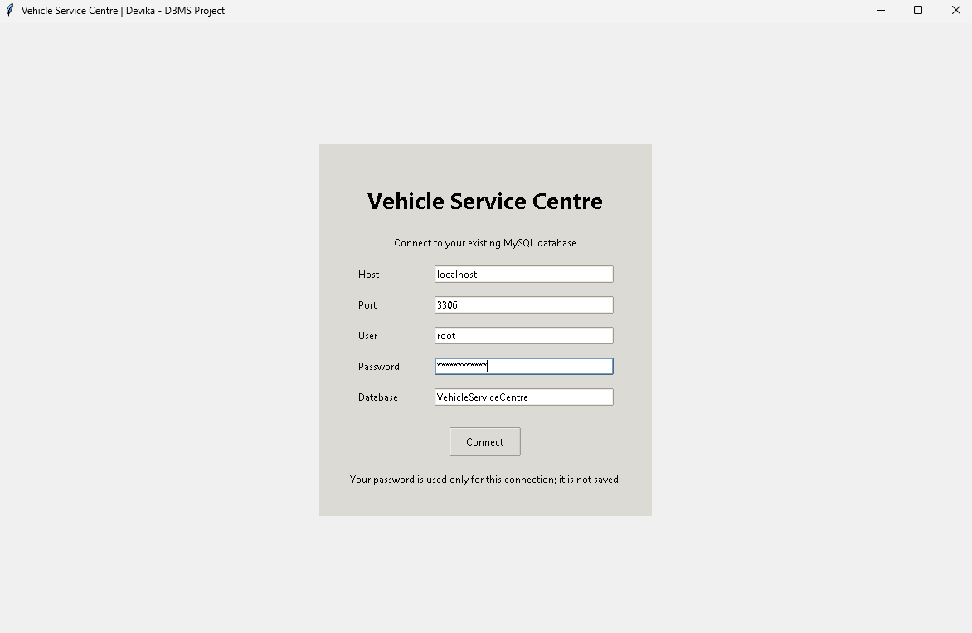
Figure 11.1: User Interface (database connection screen)
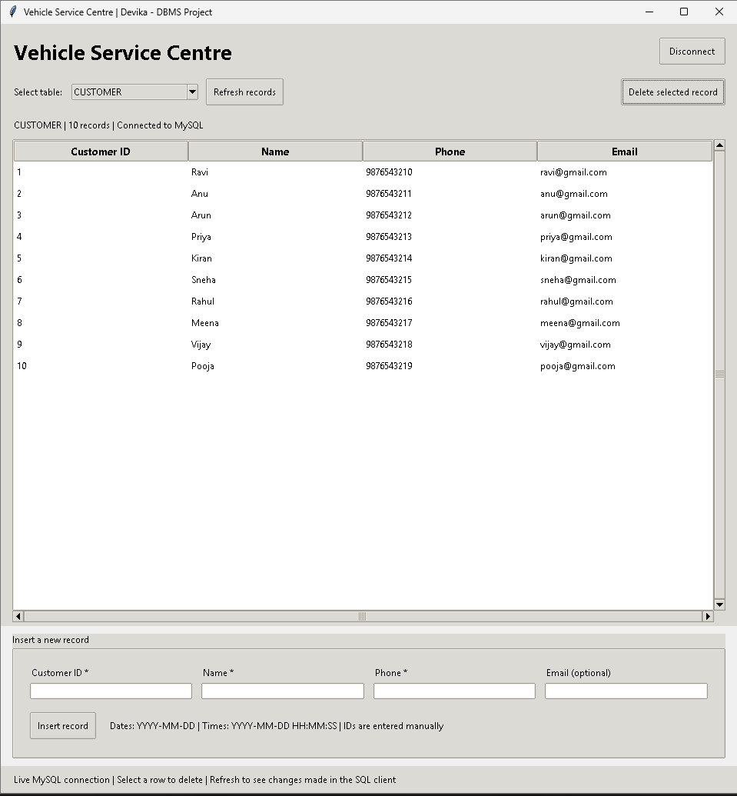
Figure 11.2: Customer Table
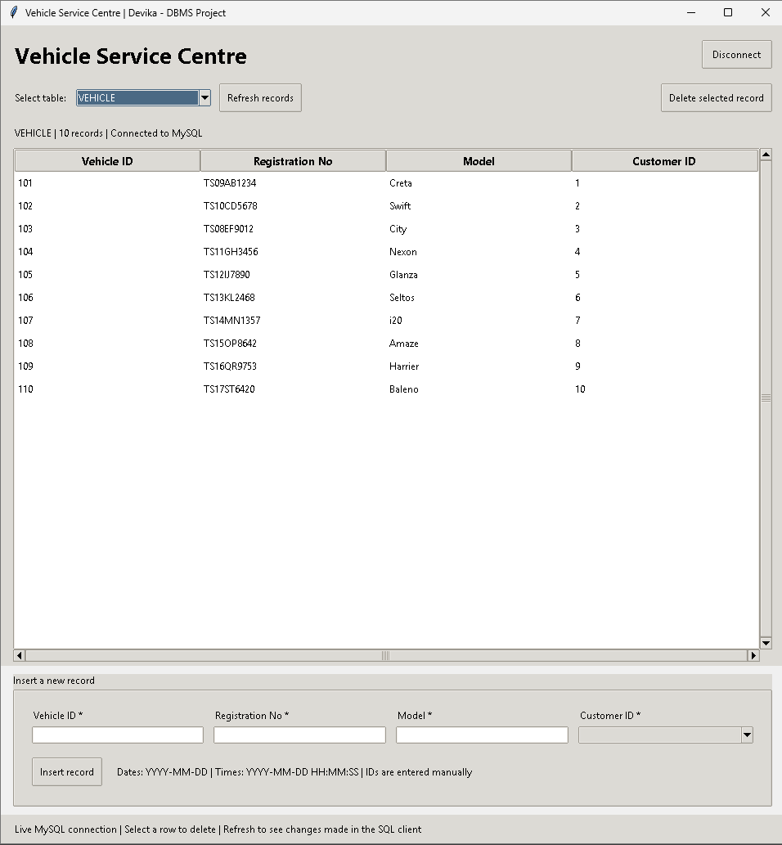
Figure 11.3: Vehicle Table
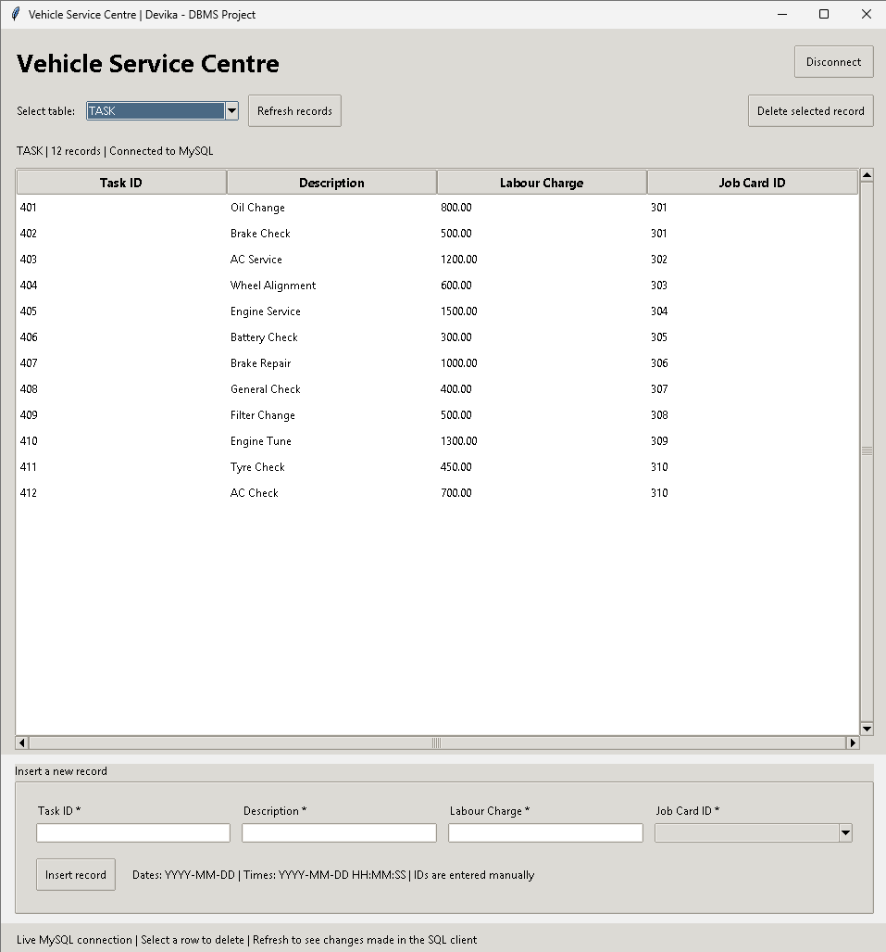
Figure 11.4: Task Table
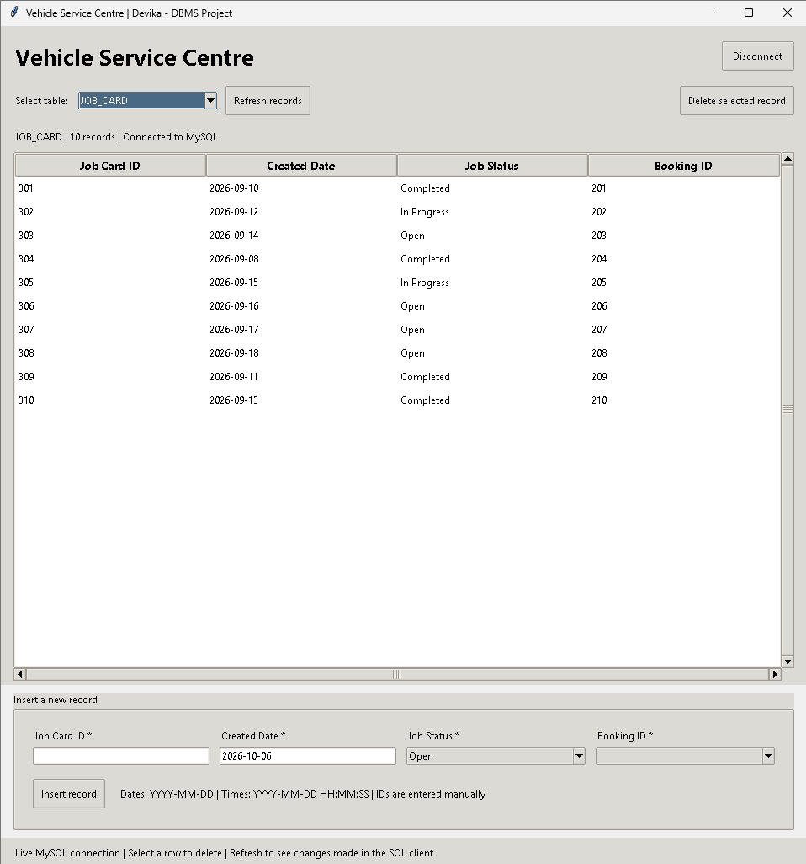
Figure 11.5: Job Card Table
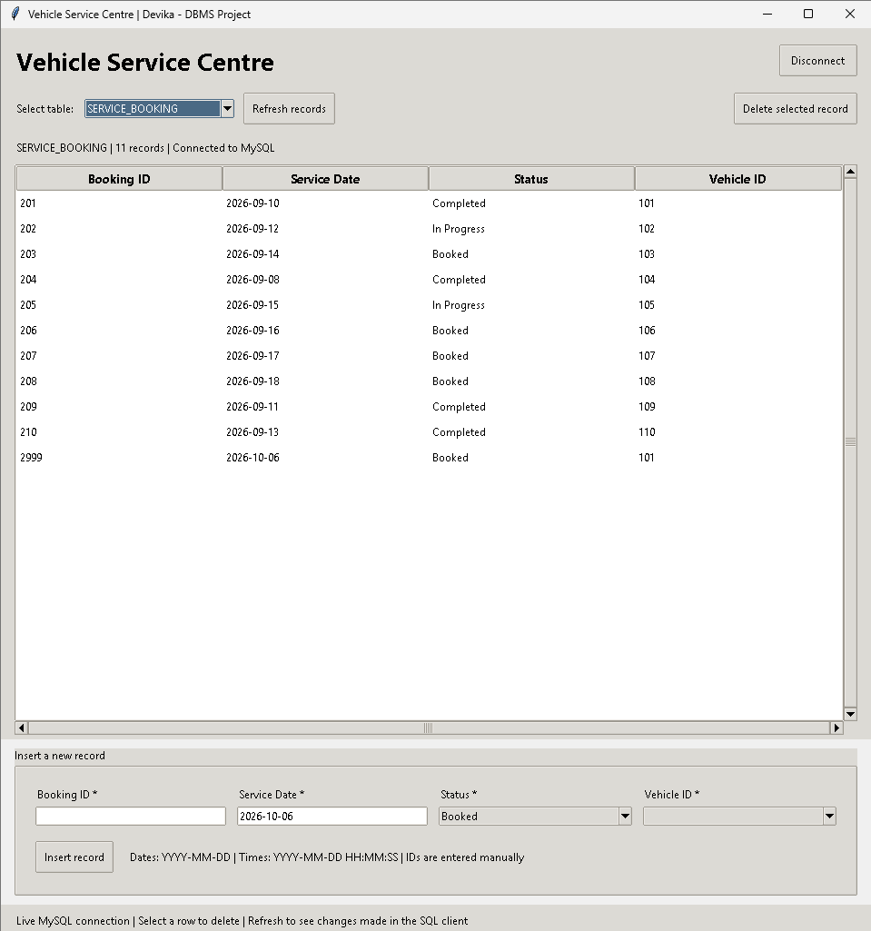
Figure 11.6: Service Booking Table
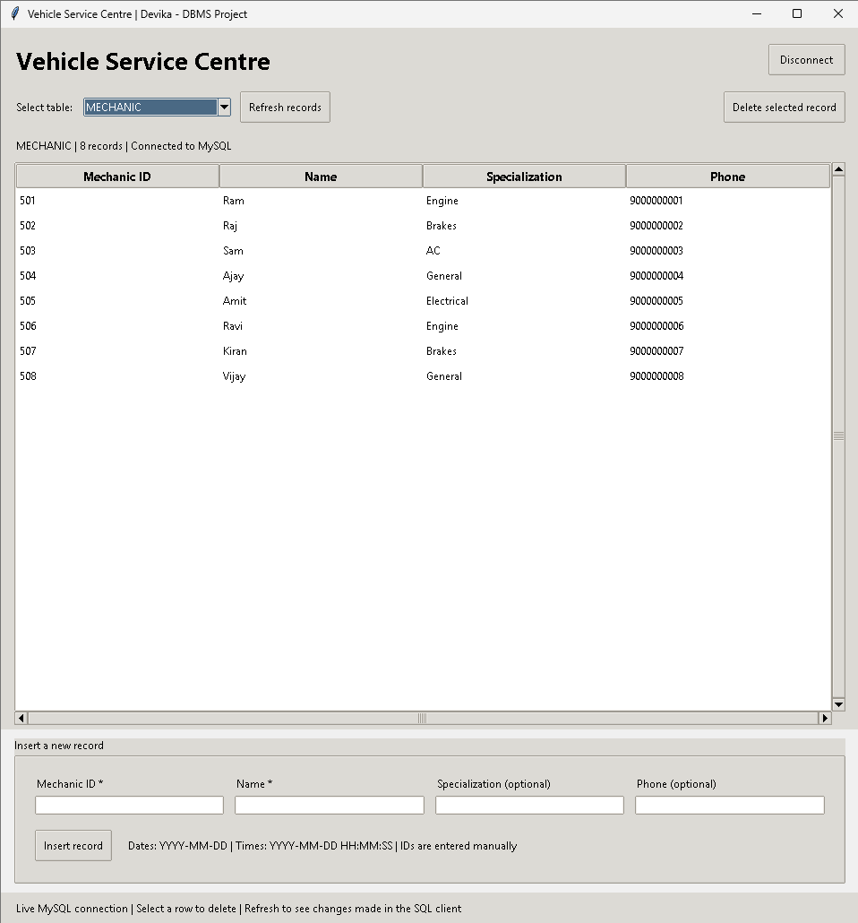
Figure 11.7: Mechanic Table
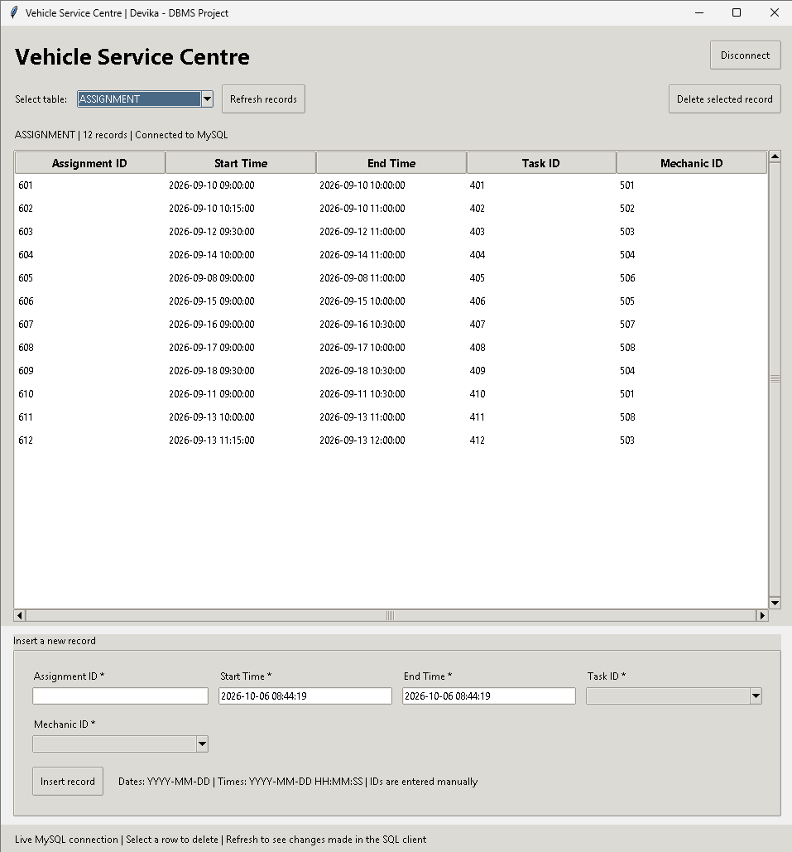
Figure 11.8: Assignment Table
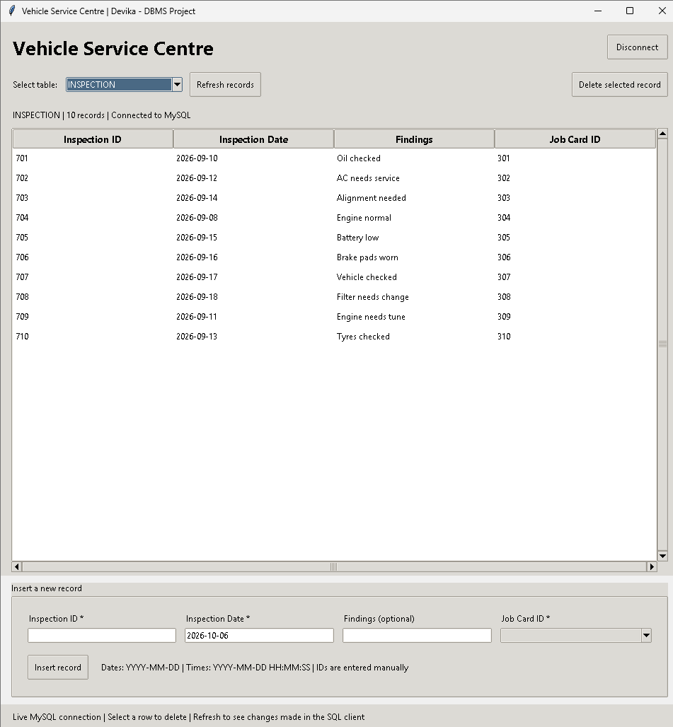
Figure 11.9: Inspection Table
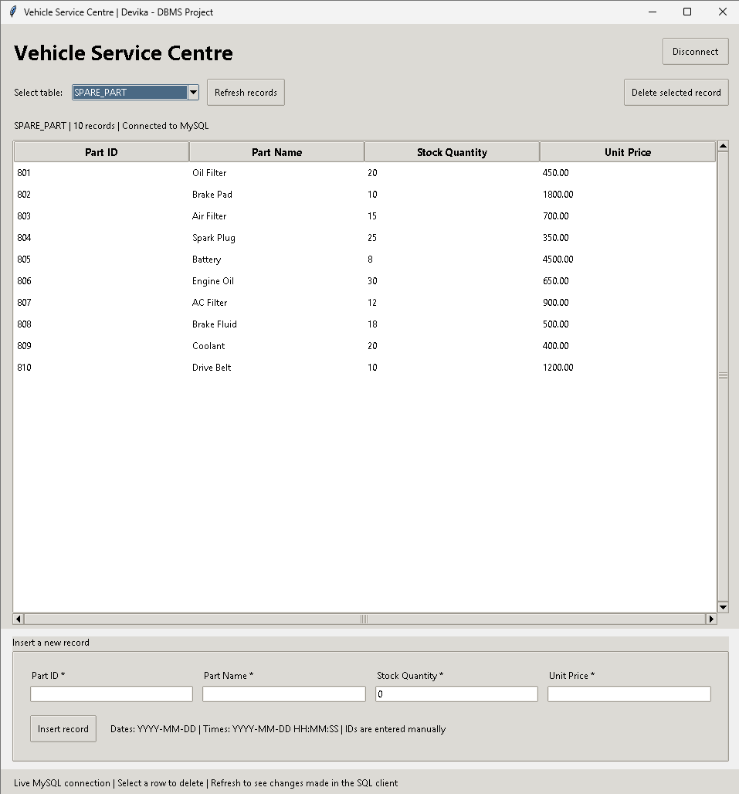
Figure 11.10: Spare Part Table
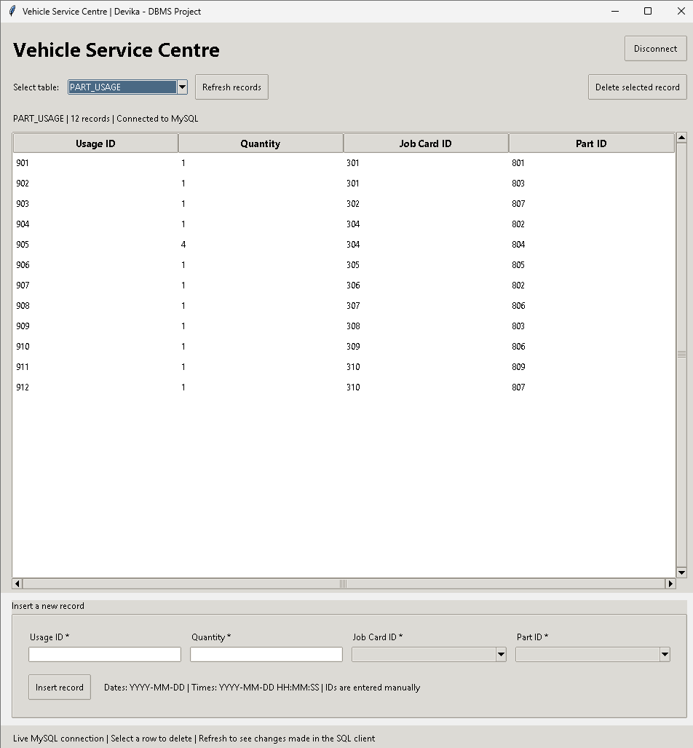
Figure 11.11: Part Usage Table
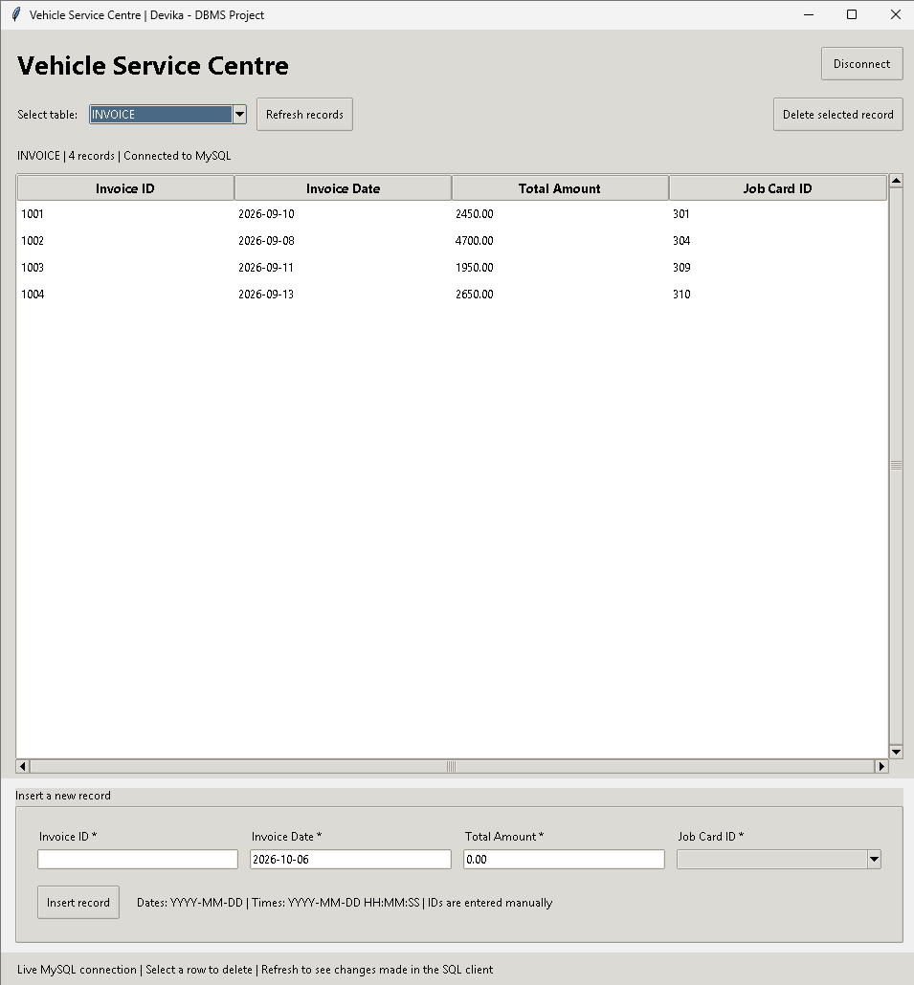
Figure 11.12: Invoice Table

12. Implementation Details

12.1 Technology Stack
Layer | Technology
Database | MySQL 8.0 (InnoDB storage engine)
Query language | SQL – DDL, DML and DQL
Application language | Python 3.x
User interface | Tkinter (desktop GUI)
Database connector | mysql-connector-python
SQL client | MySQL Workbench / MySQL Command Line Client
Design tools | Canva for ER diagram and slides
Repository | GitHub

12.2 Database Connectivity
The application opens a connection screen in which the user enters the host (localhost), port (3306), user name, password and database name (VehicleServiceCentre) and presses Connect. The connection is made with mysql-connector-python, and the password is used only for that session and is not saved. After connecting, the status bar shows the selected table, its number of records and the message “Connected to MySQL”. The Disconnect button closes the connection. Referential integrity between tables is enforced by the MySQL server using InnoDB foreign keys, so invalid operations are rejected by the database and the error is displayed in the interface.

12.3 Application Features
- View records of all 12 tables by selecting a table from a drop-down list, with a Refresh button to reload the data.
- Insert a new record using a form generated for the selected table; mandatory fields are marked with an asterisk (*) and optional fields are labelled optional.
- Select related records using drop-down lists for foreign keys (for example Customer ID in VEHICLE or Job Card ID in INVOICE), which prevents entering a non-existent parent record.
- Default values for date and status fields (for example today’s date and the status Booked or Open).
- Delete a selected record, with a confirmation prompt before the deletion is carried out.
- Input validation and display of database error messages when a constraint is violated.

12.4 Key Code Snippets
(a) A child table with keys and constraints – ASSIGNMENT. The table links a task to a mechanic and uses a CHECK constraint to prevent an end time earlier than the start time.
CREATE TABLE ASSIGNMENT (
Assignment_ID INT PRIMARY KEY,
Start_Time DATETIME NOT NULL,
End_Time DATETIME NOT NULL,
Task_ID INT NOT NULL,
Mechanic_ID INT NOT NULL,
FOREIGN KEY (Task_ID) REFERENCES TASK(Task_ID),
FOREIGN KEY (Mechanic_ID) REFERENCES MECHANIC(Mechanic_ID),
CHECK (End_Time > Start_Time)
);
(b) Status validation – SERVICE_BOOKING. A DEFAULT value and a CHECK constraint ensure that a booking can only hold one of four valid statuses.
CREATE TABLE SERVICE_BOOKING (
Booking_ID INT PRIMARY KEY,
Service_Date DATE NOT NULL,
Status VARCHAR(30) NOT NULL DEFAULT 'Booked',
Vehicle_ID INT NOT NULL,
FOREIGN KEY (Vehicle_ID) REFERENCES VEHICLE(Vehicle_ID),
CHECK (Status IN ('Booked', 'In Progress', 'Completed', 'Cancelled'))
);
(c) Multi-table join – complete service details. Four tables are joined through their foreign keys to trace a service from the customer to the job card.
SELECT c.Name, v.Registration_No, v.Model,
sb.Service_Date, jc.Job_Status
FROM CUSTOMER c
JOIN VEHICLE v
ON c.Customer_ID = v.Customer_ID
JOIN SERVICE_BOOKING sb
ON v.Vehicle_ID = sb.Vehicle_ID
JOIN JOB_CARD jc
ON sb.Booking_ID = jc.Booking_ID;
(d) Aggregation with grouping – mechanic workload.
SELECT m.Name, COUNT(a.Assignment_ID) AS Total_Assignments
FROM MECHANIC m
JOIN ASSIGNMENT a
ON m.Mechanic_ID = a.Mechanic_ID
GROUP BY m.Mechanic_ID, m.Name;

13. Testing
Testing was carried out in two parts. Constraint testing (T1–T12) attempted invalid inserts and deletes to confirm that the database rejects them with the correct error, and query testing (T13–T16) compared query results with the values expected from the sample data. All tests were executed on the final database.
ID | Test Case | Input | Expected Result | Actual Result | Status
T1 | Duplicate phone number in CUSTOMER | INSERT customer with Phone 9876543210 | Rejected (UNIQUE) | ERROR 1062: Duplicate entry for key Phone | Pass
T2 | NULL in mandatory column | INSERT customer with Name = NULL | Rejected (NOT NULL) | ERROR 1048: Column Name cannot be null | Pass
T3 | Vehicle for non-existent customer | INSERT vehicle with Customer_ID = 99 | Rejected (FOREIGN KEY) | ERROR 1452: foreign key constraint fails | Pass
T4 | Invalid booking status | INSERT booking with Status = 'Pending' | Rejected (CHECK) | ERROR 4025: CHECK constraint failed | Pass
T5 | Negative labour charge | INSERT task with Labour_Charge = -50 | Rejected (CHECK) | ERROR 4025: CHECK constraint failed | Pass
T6 | Zero payment amount | INSERT payment with Amount = 0 | Rejected (CHECK) | ERROR 4025: CHECK constraint failed | Pass
T7 | Invalid payment mode | INSERT payment with Mode = 'Cheque' | Rejected (CHECK) | ERROR 4025: CHECK constraint failed | Pass
T8 | End time before start time | INSERT assignment, End_Time < Start_Time | Rejected (CHECK) | ERROR 4025: CHECK constraint failed | Pass
T9 | Second job card for same booking | INSERT job card with Booking_ID = 201 | Rejected (UNIQUE) | ERROR 1062: Duplicate entry for key Booking_ID | Pass
T10 | Delete customer who owns a vehicle | DELETE customer with Customer_ID = 1 | Rejected (referential integrity) | ERROR 1451: cannot delete parent row | Pass
T11 | Negative stock quantity | INSERT spare part with Stock_Quantity = -1 | Rejected (CHECK) | ERROR 4025: CHECK constraint failed | Pass
T12 | Default value for booking status | INSERT booking without Status | Status = 'Booked' | Row inserted, Status = Booked | Pass
T13 | Query 1 – completed jobs | SELECT … WHERE Job_Status = 'Completed' | 4 rows | 4 rows (301, 304, 309, 310) | Pass
T14 | Query 4 – customer count | SELECT COUNT(*) FROM CUSTOMER | 10 | 10 | Pass
T15 | Query 9 – total revenue | SELECT SUM(Total_Amount) FROM INVOICE | 11750.00 | 11750.00 | Pass
T16 | Query 10 – payments by mode | GROUP BY Payment_Mode | 4 groups, 1 each | Card 1, Cash 1, Online 1, UPI 1 | Pass

All 16 test cases passed. The results confirm that primary keys, unique constraints, NOT NULL, CHECK constraints and foreign keys protect the database against invalid data, and that the queries return correct results.

14. Conclusion and Future Enhancements

14.1 Conclusion
This project successfully designed and implemented a relational database for a Vehicle Service Centre. Starting from an ER diagram, a twelve-table schema in Third Normal Form was created and implemented in MySQL with primary keys, foreign keys and CHECK, UNIQUE, NOT NULL and DEFAULT constraints. The system links customers, vehicles, bookings, job cards, tasks, mechanics, parts, invoices and payments into one consistent structure, and the ten SQL queries demonstrate that useful information such as pending jobs, mechanic workload, parts consumption and revenue can be obtained easily. Constraint testing showed that invalid data is reliably rejected.

14.2 Future Enhancements
- Extend the desktop interface with record editing, search and reports, and develop a web or mobile front-end so that staff and customers can use the system from anywhere.
- Use triggers to reduce SPARE_PART.Stock_Quantity automatically when parts are used, and to calculate INVOICE.Total_Amount from labour and parts.
- Create views and stored procedures for daily revenue, pending jobs and low-stock reports.
- Add user roles and authentication (admin, receptionist, mechanic) with access control.
- Send SMS or e-mail reminders for service due dates and ready vehicles.
- Integrate an online payment gateway and support partial payments with outstanding-balance tracking.
- Add a supplier and purchase-order module for stock replenishment.
- Add indexes on frequently searched columns and maintain regular backups.

15. References
[1] R. Elmasri and S. B. Navathe, Fundamentals of Database Systems, 7th ed., Pearson, 2016.
[2] A. Silberschatz, H. F. Korth and S. Sudarshan, Database System Concepts, 7th ed., McGraw-Hill, 2019.
[3] R. Ramakrishnan and J. Gehrke, Database Management Systems, 3rd ed., McGraw-Hill, 2003.
[4] Oracle Corporation, MySQL 8.0 Reference Manual. Available: https://dev.mysql.com/doc/refman/8.0/en/
[5] P. P. Chen, “The Entity-Relationship Model – Toward a Unified View of Data,” ACM Transactions on Database Systems, vol. 1, no. 1, pp. 9–36, 1976.

16. Appendix: GitHub Repository Link
The complete SQL script (database creation, table creation, sample data and queries), the ER diagram and this report are available in the project repository:
https://github.com/DevikaKatrala/DBMS-Course-Project
Repository contents:
- VehicleServiceCentre.sql – DDL, DML and queries
- ER diagram and relational schema
- Project presentation and report
- Screenshots

